Name____________________________________ Period______
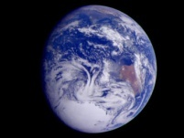
Find three facts about water or the hydrologic cycle that you did not know before you visited this site.
1.

2.

3.

Bottom of Form
Find the answers on the website to the blanks 1-5 in the columns on this table. | Volume  (1000 km³) | Percent of Total Water | Percent of Fresh Water
Oceans, Seas, & Bays | 1,338,000 | 1. _________ | -
Ice caps, Glaciers, & Permanent Snow | 24,064 | 2. __________ | 3. _______
Groundwater | 23,400 | 4. _________ | -
Fresh | (10,530) | (0.76) | 5. ________
Saline | (12,870) | (0.94) | -
Soil Moisture | 16.5 | 0.001 | 0.05
Ground Ice & Permafrost | 300 | 0.022 | 0.86
Lakes | 176.4 | 0.013 | -
Fresh | (91.0) | (0.007) | .26
Saline | (85.4) | (0.006) | -
Atmosphere | 12.9 | 0.001 | 0.04
Swamp Water | 11.47 | 0.0008 | 0.03
Rivers | 2.12 | 0.0002 | 0.006
Biological Water | 1.12 | 0.0001 | 0.003
Total | 1,385,984 | 100.0 | 100.0
Source: Gleick, P. H., 1996: Water resources. In Encyclopedia of Climate and Weather, ed. by S. H. Schneider, Oxford University Press, New York, vol. 2, pp.817-823.
Earth from space. (Image courtesy of NASA Jet Propulsion Laboratory.)
http://earthobservatory.nasa.gov/Features/Water/
- All in all about how much water is on the Earth?
__________________________

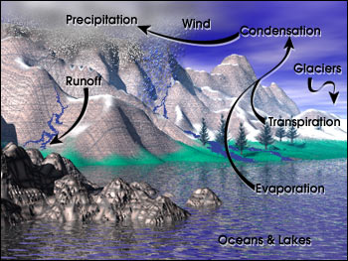

- Fill in the blanks on the Hydrologic Cycle Diagram.
- What is sublimation?

- How much water could evaporate from a corn field on an average day?

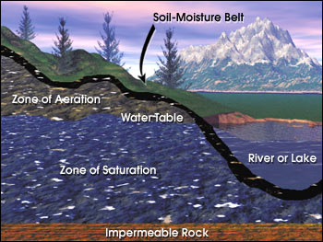
- Label the diagram.
- How much water is in the atmosphere?

